**The Equilibrium Constant**

The **Equilibrium Constant** is a numerical comparison of a reactants and products of a reaction at equilibrium.

The **Equilibrium Law** refers to the relationship used to determine the equilibrium constant of a reaction.

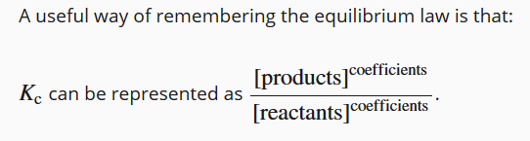

For each reaction, the equilibrium law will be slightly different as it depends upon the chemical equation for the reaction.

For Example:

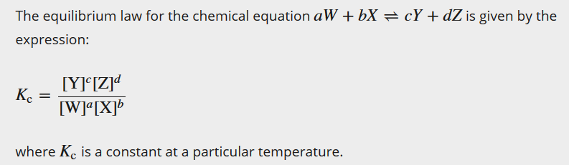

**From this mathematical equation, we can see that:**

* For the reverse equation, the equilibrium constant will be the inverse of the forward direction.

**For chemical reactions at equilibrium:**

* different chemical reactions have different values of *K*c
* the size of *K*c indicates the **proportions** of reactants and products
* 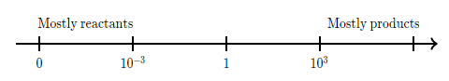for a particular reaction, *K*c is constant (doesn’t change) at any specific temperature.



It is called an **equilibrium constant** because the value is **constant** at any particular temperature regardless of the absolute concentrations.

**Why does the equilibrium constant mean?**

The equilibrium constant gives an indication of the position of the equilibrium (how far the reaction proceeds before equilibrium is established).

For example:

|  |  |
| --- | --- |
| **Kc** | **Interpretation** |
| < 1 | Reactants are favoured |
| > 1 | Products are favoured |
| = 1 | Neither reactants or products are favoured |

Some Practical Interpretations

|  |  |  |
| --- | --- | --- |
| **Kc** | **Interpretation** | **Example** |
| Between 10-4 and 104 | Significant amount of both reactants and products exist | The production of ammonia from nitrogen and hydrogen |
| Very small <10-4 | Very little reaction has occurred, there is very little product produced | Ionisation of ethanoic acid to water |
| Very large >104 | Almost complete reaction has occurred, there is very little reagent remaining. | Ionisation of hydrochloric acid in water |

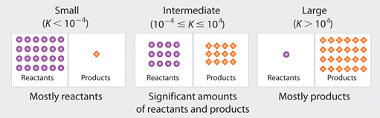

**Using Reaction Quotients**

 **What’s a Quotient?**

In mathematics, the word quotient refers to the number resulting from division. For example 2 is the quotient of 6/2

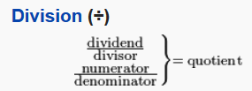

* The reaction quotient is the same mathematical relationship where equilibrium has not yet been reached (e.g. right after mixing the reactants together, or mixing a combination of reactants and products together that are not at equilibrium ratios).
* Because the system has not reached equilibrium this number cannot be called an equilibrium constant (K), instead it is referred to as the **Reaction** **(Concentration) Quotient (Q)**.

Just like the equilibrium constant

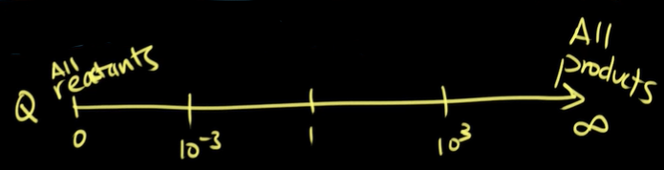

If the reaction quotient, Q is:

* greater than K, the system shifts to the left to achieve equilibrium and more reactants are formed
* smaller than K, the system shifts to the right to achieve equilibrium and more products are formed. This is normally the case in most laboratory experiments.
* When the Q = K the system has reached equilibrium.

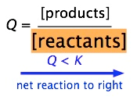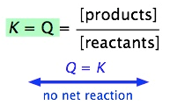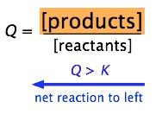

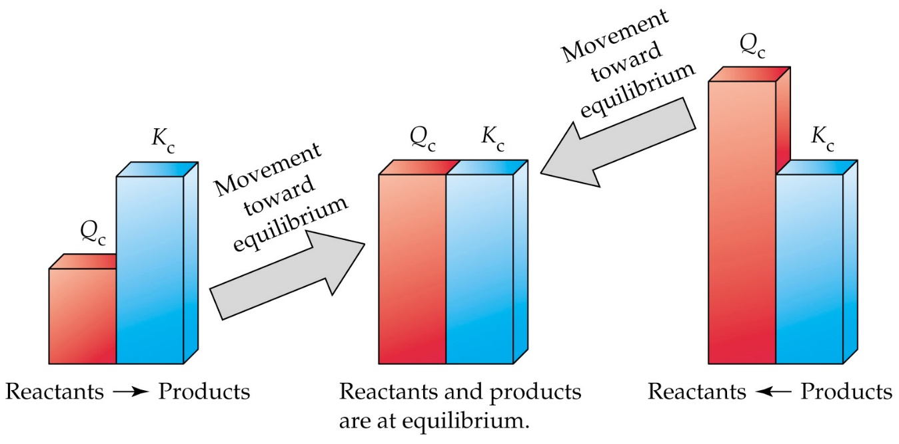

**Recommended Videos**

* [intro-to-reaction-quotient-q](https://www.khanacademy.org/science/chemistry/chemical-equilibrium/factors-that-affect-chemical-equilibrium/v/intro-to-reaction-quotient-q)
* [comparing-q-vs-k-example](https://www.khanacademy.org/science/chemistry/chemical-equilibrium/factors-that-affect-chemical-equilibrium/v/comparing-q-vs-k-example)